**Supporting Information for**

**Multi-objective Energy Planning for China’s Dual Carbon Goals**

Xiaoping Jia1, Yanmei Zhang1, Raymond R. Tan2, Zhiwei Li3, Siqi Wang5, Fang Wang1,4*, Kai Fang5,6*

*1 School of Environment and Safety Engineering, Qingdao University of Science and Technology, Qingdao 266042, China*

*2 Department of Chemical Engineering, De La Salle University, Manila 0922, Philippines*

*3 School of Chemistry and Chemical Engineering, Hefei University of Technology, Hefei, China*

*4 Sino-Geman Engineering College, Qingdao University of Science and Technology, Qingdao 266042, China*

*5 School of Public Affairs, Zhejiang University, Hangzhou 310058, China*

*6 Center of Social Welfare and Governance, Zhejiang University, Hangzhou 310058, China*

Corresponding Authors

Ph.D. Fang Wang

E-mail: wangf@qust.edu.cn

Ph.D. Kai Fang

E-mail: fangk@zju.edu.cn

11 pages (including cover page)

8 Tables (S1-S8)

5 Figures (S1-S5)

**Contents**

S1: Industrial classification

S2: Disaggregation of China's input-output tables

S3: Data sources

S4: Relevant electricity data

S5: Forecasting energy consumption

S6: Extended figures

**S1: Industrial classification**

Table S1. Industrial Classification

|  |  |  |  |  |
| --- | --- | --- | --- | --- |
| **Primary industry (Agriculture): Agriculture, Forestry, Animal Husbandry and Fisheries** | | | | |
| **Secondary industry: Industry (including extractive industries, manufacturing, electricity, etc.) and construction** | | | | |
| Mining | Nonmetallic Mineral Manufacturing | Machinery and equipment manufacturing | Construction | |
| Other Manufacturing | Metal Products Manufacturing | Food, beverage manufacturing and tobacco products industry | Chemical Industry | |
| Textile, clothing and leather products manufacturing | Coking, gas and oil processing industry | Electricity, heat and water production and supply industry |  | |
| **Tertiary industry: In addition to the Primary and Secondary industry (distribution sector and service sector)** | | | | |
| Housing, leasing and business services | Transportation, storage and postal services, information transmission, computer services and software industry | Wholesale and retail trade, accommodation and catering | Financial Industry | Other Services |

**S2: Disaggregation of China's input-output tables**

Table S2. Disaggregated IO table

|  |  |  |  |  |  |  |  |  |  |  |  |
| --- | --- | --- | --- | --- | --- | --- | --- | --- | --- | --- | --- |
|  | Intermediate demand | | | Fixed Investment of Electricity (FIE) | | | | | | Final demand except FIE | Total output |
|  | Primary industry | Secondary industry | Tertiary industry | Coal-Fired | Nature Gas | Nuclear | Wind | Solar photovoltaic | Other Renewable |
| Primary industry | $$a_{11}$$ | $$a_{12}$$ | $$a_{13}$$ | $$k_{11}$$ | $$k_{12}$$ | $$k_{13}$$ | $$k_{14}$$ | $$k_{15}$$ | $$k_{16}$$ | $$\tilde{f_{1}}$$ | $$X_{1}$$ |
| Secondary industry | $$a_{21}$$ | $$a_{22}$$ | $$a_{23}$$ | $$k_{21}$$ | $$k_{22}$$ | $$k_{23}$$ | $$k_{24}$$ | $$k_{25}$$ | $$k_{26}$$ | $$\tilde{f_{2}}$$ | $$X_{2}$$ |
| Tertiary industry | $$a_{31}$$ | $$a_{32}$$ | $$a_{33}$$ | $$k_{31}$$ | $$k_{32}$$ | $$k_{33}$$ | $$k_{34}$$ | $$k_{35}$$ | $$k_{36}$$ | $$\tilde{f_{3}}$$ | $$X_{3}$$ |
| Added | $$Z_{1}$$ | $$Z_{2}$$ | $$Z_{3}$$ |  | | | | | | | |

The above table satisfies the row-wise and column-wise input-output balance equations.

$\sum_{j=1}^{3}{a_{ij}x_{i}+\sum_{j=1}^{3}{k_{ij}+\tilde{f_{i}}=x_{i}}}$ (1)

$\sum_{i=1}^{3}{a_{ij}x_{j}+z_{j}=x_{j}}$ (2)

Where $a_{ij}=x_{ij}/x_{j}$, in which $x_{ij}$ represents the intersectoral monetary flows from sector *i* to sector *j*, $x_{j},$ $x_{i}$ are the total output of sector *j* and *i*. $k_{ij}$ is the amount of investment goods used by sector *i* to meet the expanded production needs of sector *j*, $\tilde{f_{i}}$ represents the amount of product in sector *i* used as final net product, and $z_{j}$ is the value added of sector *j*.

**S3: Data Sources**

Table S3. Data Sources

|  |  |  |  |
| --- | --- | --- | --- |
| **Demand** | **Data Categories** | **Time(Year)** | **Sources** |
| Economy | Input-Output Table | 2017 | (Chinese Input-Output Associatioon) CIOA [1] |
| GDP, Industry Added- Value | 2000-2019 | China Statistical Yearbook 2020 [2] |
| Energy | Energy consumption in total and by industry | 2000-2019 | China Energy Statistics Yearbook 2020 [3] |
| Energy consumption per capita | 2000-2019 | BP Statistics review of world energy 2021 [4] |
| Populations | 2020-2060 | United Nations Population Division [5] |
| Carbon | Carbon Emissions in Total and by Industry | 2000-2019 | China Carbon Emission Accounting Database (CEADs) [6] |
| Electricity | Basic data of different electricity generation technologies: electricity generation capacity, installed capacity | 2000-2019 | China Electric Power Yearbook 2020 [7] |
| Electricity generation capacity of the different electricity generation technologies | 2020-2050 | International Energy Agency (IEA)：World Energy Outlook 2021 [8] |

Table S4. Key data for China of economic, energy and carbon emissions

|  |  |  |  |  |  |  |  |  |  |
| --- | --- | --- | --- | --- | --- | --- | --- | --- | --- |
| **Industry** | **Added value**  **(billion CNY)** | | | **Energy consumption**  **(Mtce)** | | | **Carbon emission**  **(Mt CO2)** | | |
| 2000 | 2010 | 2019 | 2000 | 2010 | 2019 | 2000 | 2010 | 2019 |
| Primary industry | 1472 | 3843 | 7047 | 42.33 | 72.66 | 9018 | 43.5 | 79.1 | 87.12 |
| Secondary industry | 4566 | 19162 | 38067 | 1052.21 | 2669.11 | 331646 | 2472.7 | 6921.2 | 8260.8 |
| Tertiary industry | 3990 | 18206 | 53537 | 208.16 | 500.01 | 85115 | 314 | 682.7 | 980 |
| Residential | - | - | - | 166.95 | 364.70 | 61709 | 173.2 | 221.5 | 478 |
| Total | 10028 | 41212 | 98651 | 1469.64 | 3606.48 | 487488 | 3003.4 | 7904.5 | 9806 |

**S4: Relevant electricity data**

**(1) Determining Fixed Investment of Electricity (FIE)**

For each common sector (Primary, Secondary and Tertiary industry) the investment in each electricity generation technology is determined by the following equation.

$k_{ij}^{t}=s_{ij}*u^{t}$ (3)

Where $k_{ij}^{t}$ is the investment in the *ith*common sector that meets the expansion of technology *j* in year *t*, $s_{ij}$ represents share of investment in sector *i* of the *jth* generation technology. The investment structure of the six electricity generation technologies is shown in Table S5, $u^{t}$ is the diagonal matrix of the total investment in various electricity generation technologies in year *t*, where the 2019 investment is shown in Table S6.

Table S5. Electricity technology investment structure [9]

|  |  |  |  |  |  |  |
| --- | --- | --- | --- | --- | --- | --- |
| Technology  Industry | Coal-Fired | Gas-Fired | Hydropower | Wind | PV | Other |
| Primary industry | 0.1 | 0.1 | 0.1 | 0.1 | 0.08 | 0.1 |
| Secondary industry | 0.65 | 0.67 | 0.62 | 0.58 | 0.6 | 0.6 |
| Tertiary industry | 0.25 | 0.23 | 0.28 | 0.32 | 0.32 | 0.3 |

Table S6. relevant electricity parameters

|  |  |  |  |  |  |  |
| --- | --- | --- | --- | --- | --- | --- |
| Indicator | **Coal-fired** | **Gas-fired** | **Nuclear** | **Wind** | **Solar** | **Other** |
| Investment (billion CNY) in 20197 | 50.628 | 10.423 | 38.239 | 124.4367 | 18.403 | 86.2 |
| New installed capacity (GW) in 201910 | 32.36 | 6.30 | 4.09 | 25.72 | 26.52 | 10.02 |
| Installed capacity in 2019 (GW)7 | 11366.6 | 866.6 | 522.0 | 2297.7 | 2304.5 | 2429.2 |
| Generating capacity in 2019 (109kW)7 | 4899 | 226 | 348 | 406 | 224 | 1047 |
| Learning rate 2019-203011 | 0.5% | 2% | 0.5% | 1% | 4% | 0.5% |
| Learning rate 2030-205014 | 0.25% | 1% | 0.25% | 0.5% | 2% | 0.25% |
| Life time(years)12 | 40 | 30 | 40 | 25 | 25 | 25 |

Source: IEA: Projected Cost of Generating electricity 2020 [10];

Source: Chinese Electric Power Yearbook 2020 [7];

Source: Li et al [11].

**(2) Setting the target of electricity**

In the context of the global commitment to carbon neutrality, IEA released its annual flagship report, World Energy Outlook 2021, which applied the World Energy Model (WEM) to study future energy development trends and simulated four scenarios: Net Zero Emission (NZE) 2050, Announced Commitment Scenario (APS), Stated Strategy Scenario (STEPS), and Sustainable Development Scenario (SDS), where SDS takes into account China's latest DCG, so the projected electricity generation of this scenario is selected as the target value as shown in Table S7.

Table S7. future electricity generation structure

|  |  |  |  |  |  |  |
| --- | --- | --- | --- | --- | --- | --- |
| Year | Electricity Generation (TWh) | | | | | |
| Coal | Nature gas | Nuclear | Wind | PV | Other renewable |
| 2019 | 4899 | 226 | 348 | 406 | 224 | 1047 |
| 2020 | 4958 | 230 | 366 | 471 | 270 | 1115 |
| 2030 | 3867 | 413 | 751 | 1778 | 1523 | 1134 |
| 2050 | 738 | 703 | 1450 | 4236 | 5286 | 1367.6 |
| Annual normal operating hours | 4310 | 2608 | 6666 | 1767 | 972 | 3589 |

Since the report does not give a target value of installed electricity generation capacity that is consistent with this study, the future target value of installed electricity generation capacity is estimated based on the relationship between installed electricity generation capacity and electricity generation.

The theoretical electricity generation is calculated based on the rated generation capacity of the installed electricity generating units at full generation. Annual electricity generation is equal to the installed generation capacity multiplied by the total hours of the year; The designed electricity generation is calculated according to the normal working capacity of the installed electricity generation machine. Annual electricity generation is equal to the installed generation capacity multiplied by the normal working hours.

This study assumes that the future normal operating hours of utilization of various electricity generation technologies are calculated as the average of 2015-2019, and the specific values are shown in the table above, and the target values of future installed electricity generation capacity in China can be obtained by conversion.

Table S8. GDP target value for specific year (¥ billion)

|  |  |  |  |  |
| --- | --- | --- | --- | --- |
| scenario | 2019 | 2030 | 2050 | 2060 |
| Low GDP growth | 98651.6 | 160000 | 300000 | 370000 |
| Medium GDP growth | 98651.6 | 169000 | 338000 | 435000 |
| High GDPgrowth | 98651.6 | 182000 | 400000 | 550000 |

**S5: Forecasting energy consumption**

From historical data, China's total primary energy consumption and per capita energy consumption are increasing year by year, and in 2009, the total 97.52 EJ exceeded the US 89.92 EJ for the first time, becoming the world's largest energy consumer [4]. China's per capita energy consumption in 2013 was 3.5 times higher than in 1990, exceeding the world' s average, reflecting China's remarkable achievements and significant improvements in the country's industrialization and the living standards of its residents. In the background of China's industry restructuring, energy conservation and emission reduction, the development trend of energy consumption does not always continue the past, and various institutions have different predictions for the future of China's total primary energy consumption, summarized in three trends: " continuous growth" "first up and then down " "sustained growth followed by a steady decline". In this paper, we estimate the future trend of total primary energy consumption in China based on two indicators: per capita energy consumption and total population.

First of all, China's per capita energy consumption from 2008 to 2020 was analyzed by regression, and the future per capita energy consumption in China from 2020 to 2060 was obtained, and then combined with the population projection data of the United Nations Population Division (taking Constant-fertility as an example), the future trend of China's primary energy consumption is shown in Figure S1. In simulation, the energy consumption of specific years 2020, 2030, 2035, 2050, and 2060 in this forecast result is used as the target value to simulate the optimal pathway under multi-objectives. As shown in Figure S1, the per capita energy consumption and total primary energy consumption are gradually decreasing in the future due to the improvement of quality of life and energy conservation awareness.

**Figure S1.** Primary energy consumption pathway. The future total population of China peaks in 2030 at 14,623.36 million people, and the total primary energy consumption peaks in 2035 at 180.64 EJ.

**S6: Extended figures**

We set up 54 scenarios, and when solving the model, same results for different target priority order occurs, the scenario for target priority order is: economic, energy and carbon has the same result as the scenario: energy, economic and carbon. Thus, there are 27 different results after combining the scenarios. This section lists 18 results. The remaining 9 results are displayed in the main text.

**Figure S2.** China’s industrial value-added and carbon emission optimal pathways under low economic growth for 2020–2060.

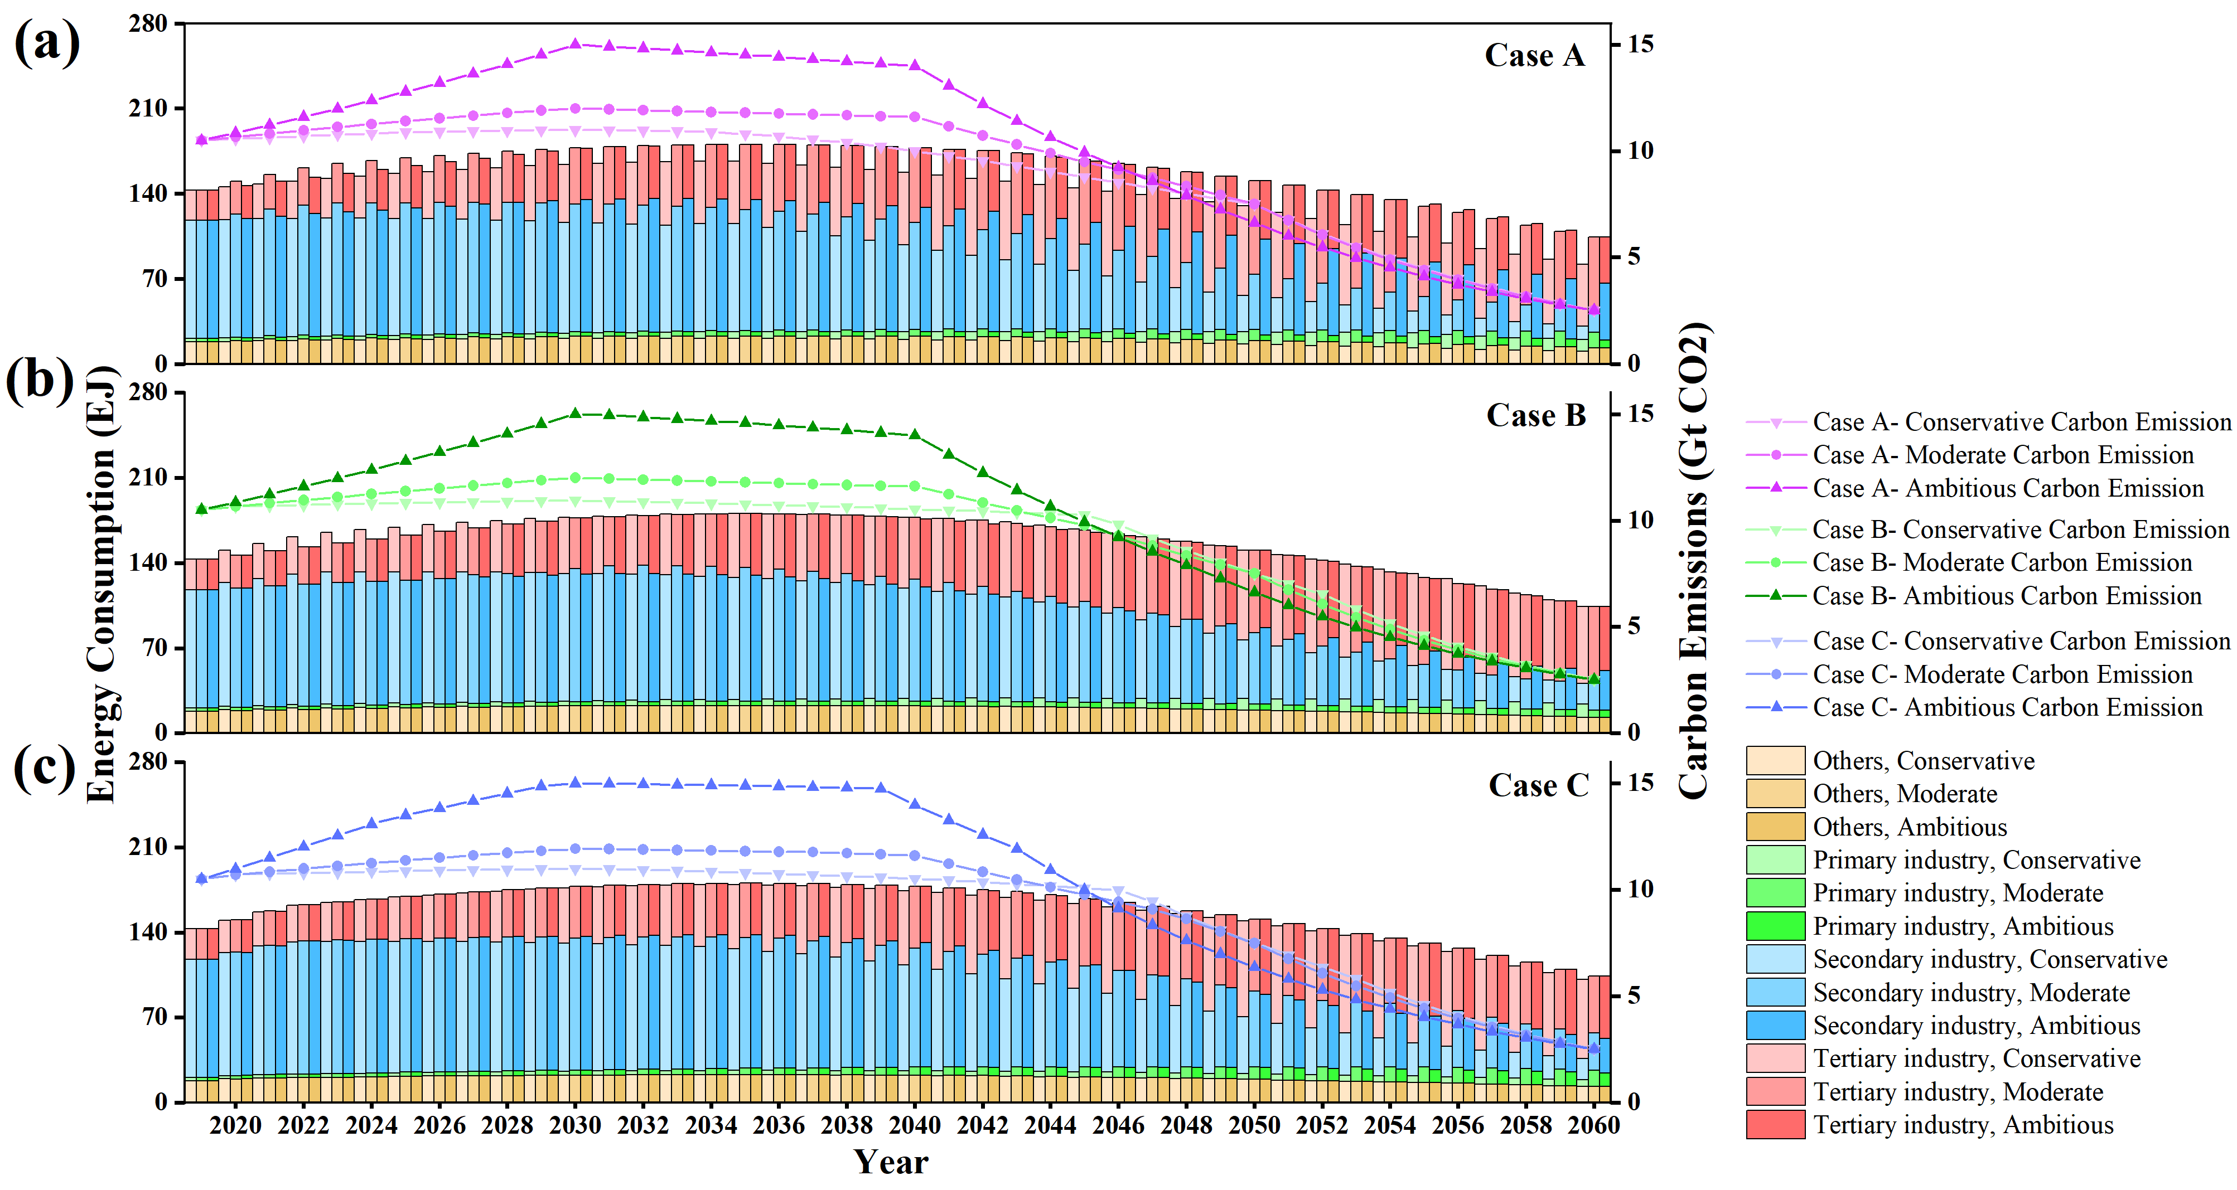

**Figure S3.** China’s industrial energy consumption and carbon emission optimization pathways under low economic growth for 2020–2060.

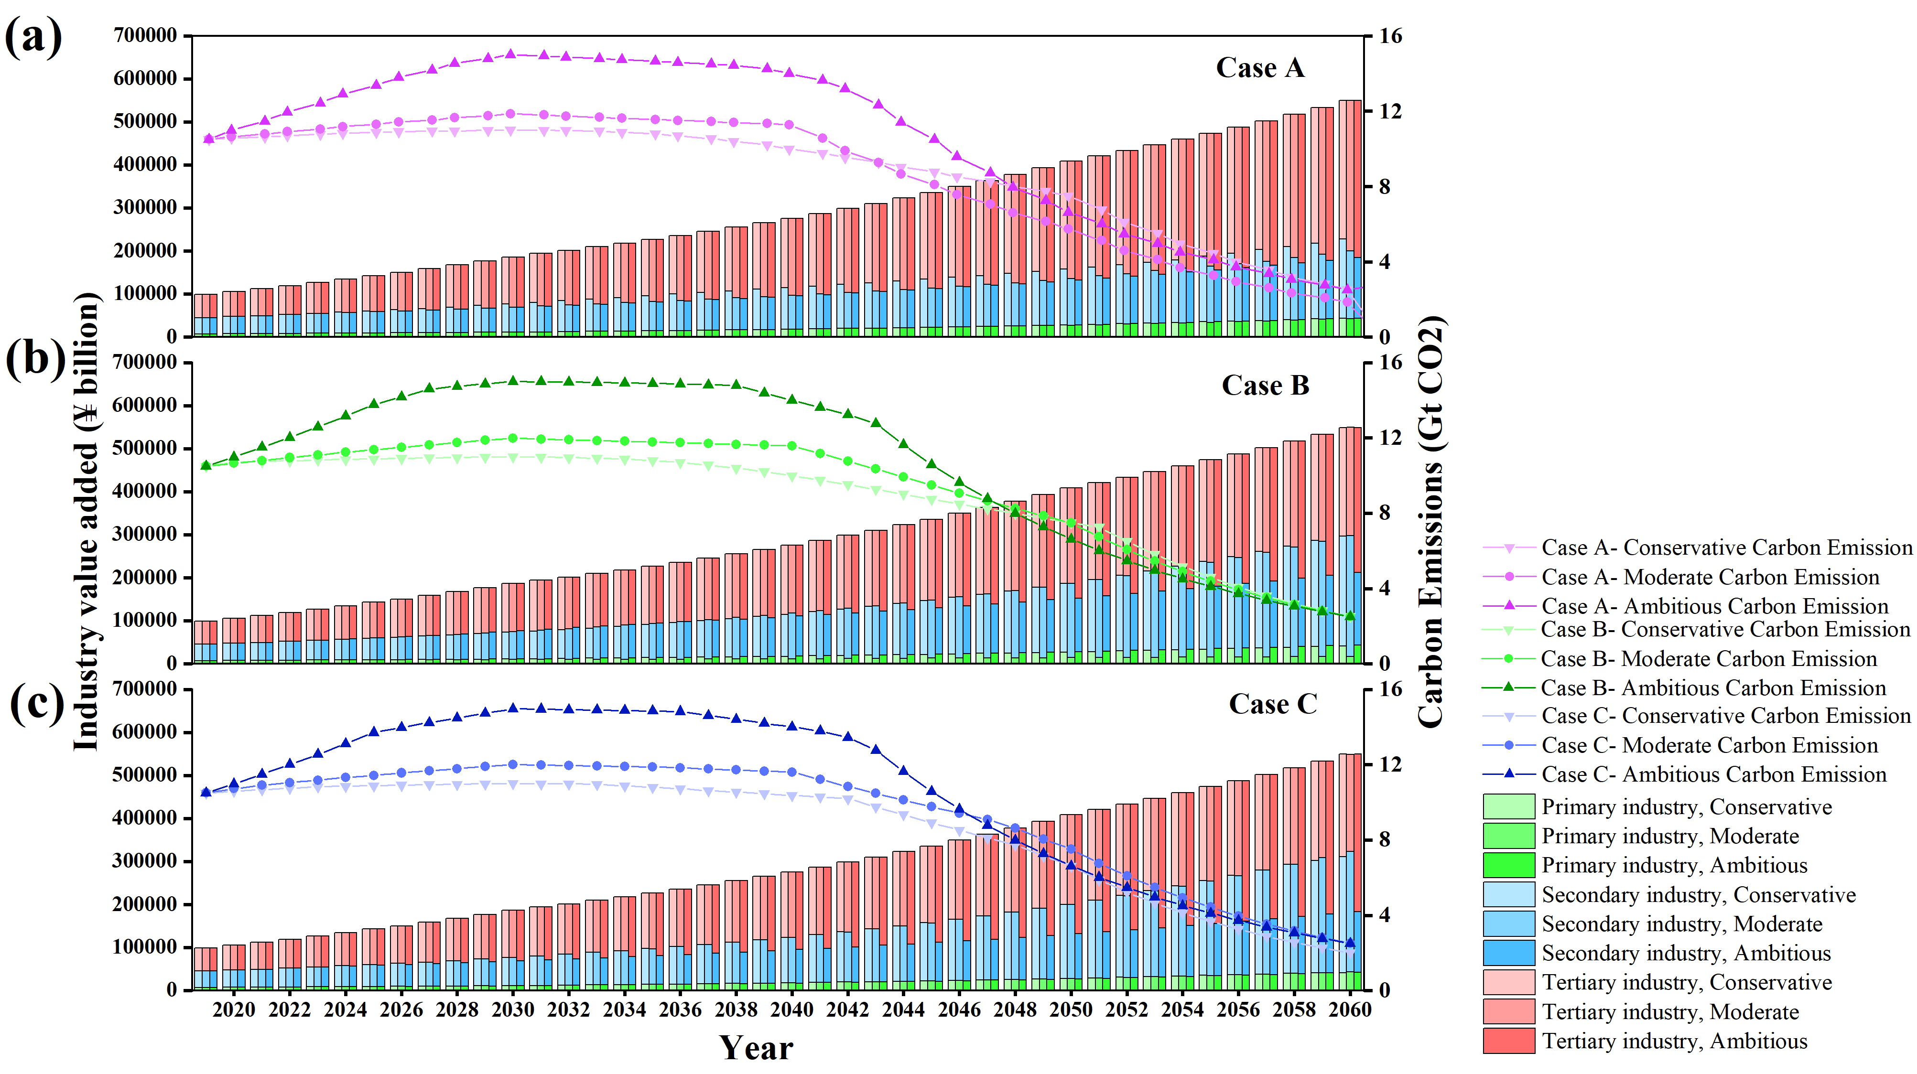

**Figure S4.** China’s industrial value-added and carbon emission optimal pathways under high economic growth for 2020–2060.

**Figure S5.** China’s industrial energy consumption and carbon emission optimization pathways under high economic growth for 2020–2060.

**References cited in supporting information**

[1] Chinese Input-Output Association (CIOA). Input-Output tables from 2002-2018. Abailable at: <http://cioa.ruc.edu.cn/zlxz/trccb/index.htm>

[2] National Bureau of Statistics of China (NBSC). China Statistical Yearbook 2020; China Statistics Press, 2020.

[3] National Bureau of Statistics of China (NBSC). China Energy Statistical Yearbook 2020; China Statistics Press, 2020.

[4] BP. Statistical Review of World Energy 2021. British Petroleum, 2021.

[5] United Nations Population Division. World Polpulation Prospects 2019; <http://creativecommons.org/licenses/by/3.0/igo/>.

[6] China Carbon Emission Accounting Database (CEADs). Carbon Emission Inventory for China by Sector 1997 – 2019; 2020. https://www.ceads.net.cn/data/nation/.

[7] China Electric Power Yearbook (CEPY). China Electric Power Yearbook 2020; China Electric Power Press: Beijing, 2021.

[8] IEA. World Energy Outlook 2021; International Energy Agency, 2021.

[9] Kang, J.; Ng, T. S.; Su, B.; Yuan, R. Optimizing the Chinese Electricity Mix for CO2 Emission Reduction: An Input–Output Linear Programming Model with Endogenous Capital. Environmental Science & Technology 2019, 54 (2), 697-706.

[10] IEA. Projected Costs of Generating Electricity 2020; International Energy Agency: Paris, 2020.

[11] Lindner, S.; Legault, J.; Guan, D. Disaggregating the Electricity Sector of China's Input–Output Table for Improved Environmental Life-Cycle Assessment. Economic Systems Research 2013, 25 (3), 300-320.